Model Development Phase Template

|  |  |
| --- | --- |
| Date | 22 April 2024 |
| Team ID | Team-738178 |
| Project Title | Envisioning Success : Predicting University Scores With Machine Learning |
| Maximum Marks | 4 Marks |

# Initial Model Training Code, Model Prediction and Evaluation Report

The initial model training code will be showcased in the future through a screenshot. The model performance evaluation report will include Performance reports, Mean Squared Error, and Comparison between Actual and Predicted Values for multiple models, presented through respective screenshots.

# Initial Model Training Code:

# 

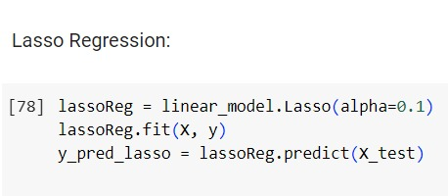

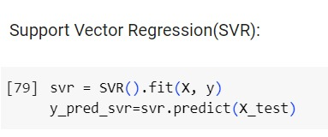

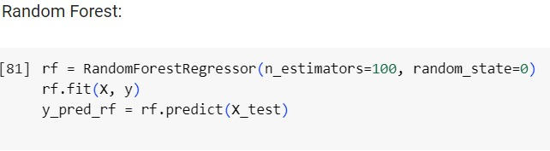

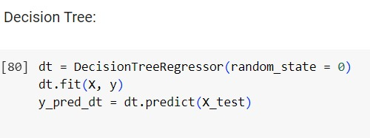

**Model Prediction and Evaluation Report:**

|  |  |  |  |
| --- | --- | --- | --- |
| **Model** | **Performance Report** | **MSE** | **Comparison between Actual and Predicted Values** |
| Lasso Regression |  | 28.89 |  |
| Linear  Regression |  | 28.92 |  |
| SVR |  | 26.88 |  |
| Random  Forest |  | 1.69 |  |

|  |  |  |  |
| --- | --- | --- | --- |
| Decision  Tree |  | 3.16 |  |